

**ADVANCED PYTHON LAB**

**ERROR ANALYSIS FROM EXERCISE 1**

**NAME: M.GOKULESH.**

**REG NO: 22MIC0102.**

PACKAGE USED: **BOKEH**

1.Bokeh is a powerful data visualization library in Python that helps you create interactive, web-ready plots and dashboards easily.

2.Bokeh allows zooming, panning, hovering, and tooltips without extra coding.

3.Ideal for dashboards and data exploration

4.Supports line charts, bar charts, scatter plots, heatmaps, and more.

5.Supports live data updates and dynamic plotting using stream() and patch().

**ERRORS MADE:**

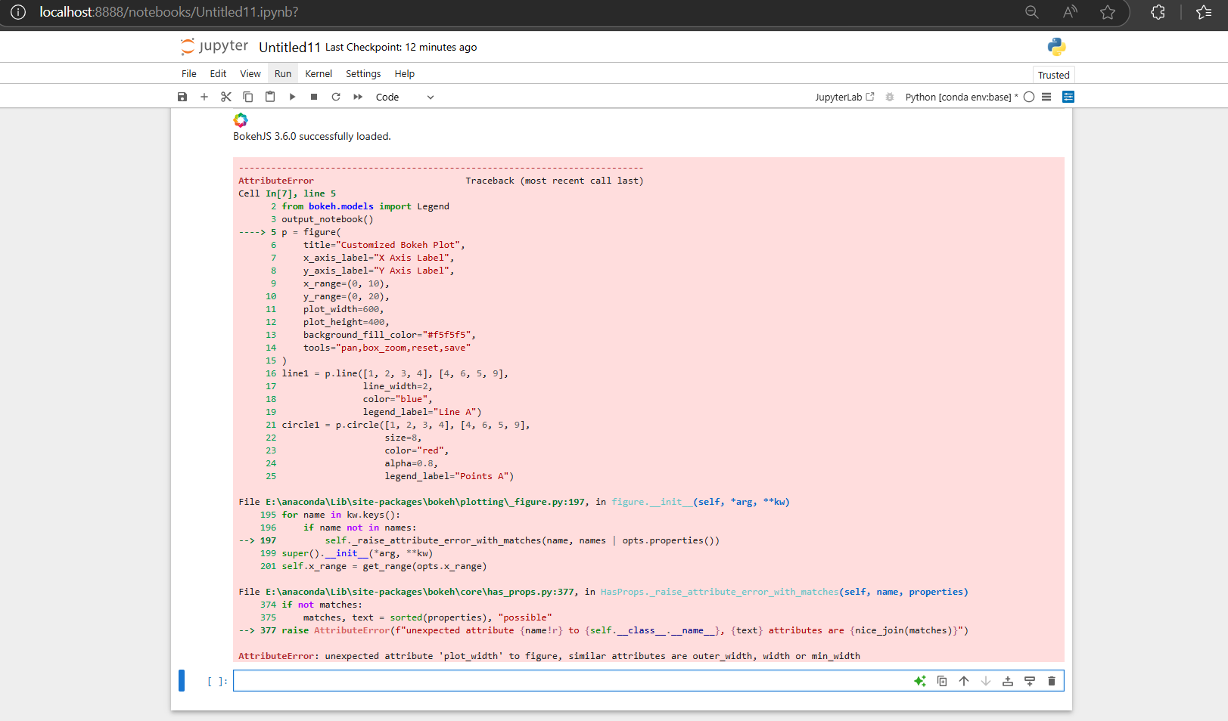

**RECTIFICATION:**

Initially while passing arguments I assigned plot_width and plot_height which has supporting in older version of bokeh but new version of bokeh directly allows us to assign width and height without provoding plot parameter and the error has been rectified.